**Graded Project on Building CI-CD Pipeline Tool**

Create a complete CI-CD pipeline using bash, python and crontabs. The list of tasks is specified below:

**GIT REPOSITORY :** <https://github.com/igSpanser/HV_CICD_Project.git>

Task 1: Set Up a Simple HTML Project

Create a simple HTML project and push it to a GitHub repository.

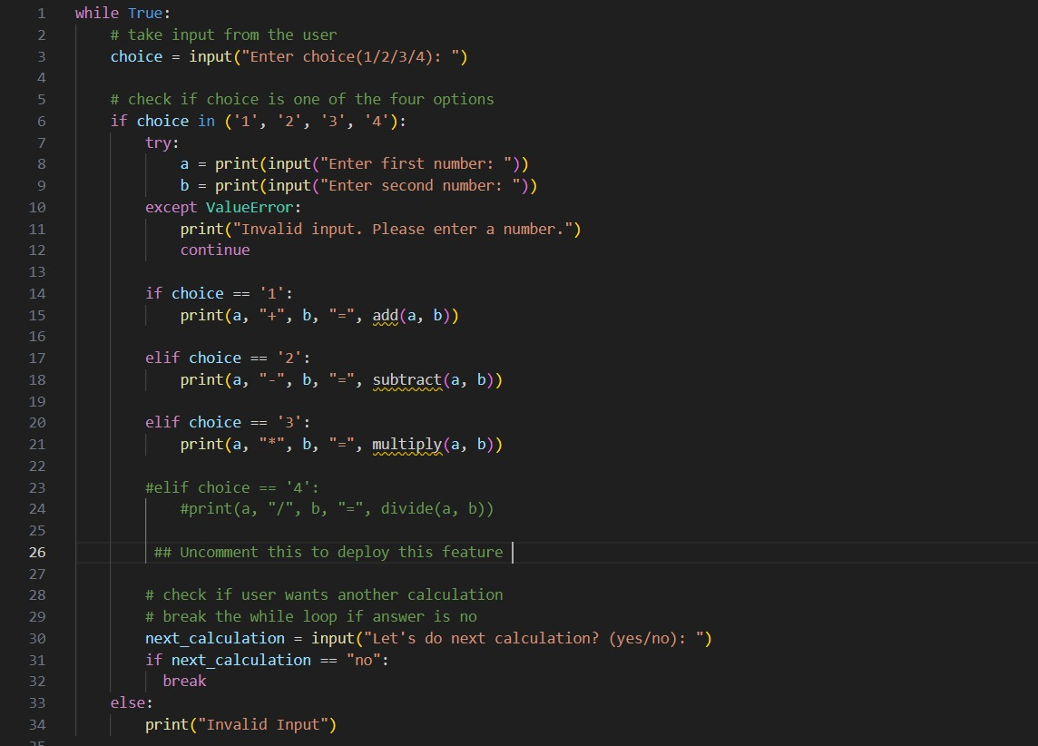

Commands Used : git add Calculator.py

git commit -m “Adding code to repo”

git push -u origin main

Task 2: Set Up an AWS EC2/Local Linux Instance with Nginx

**LAUNCH INSTANCE :**

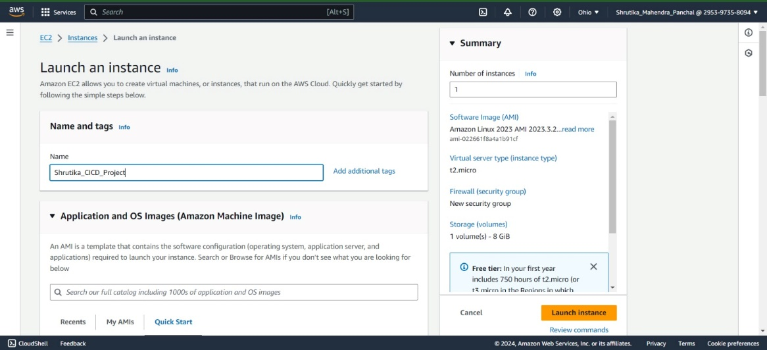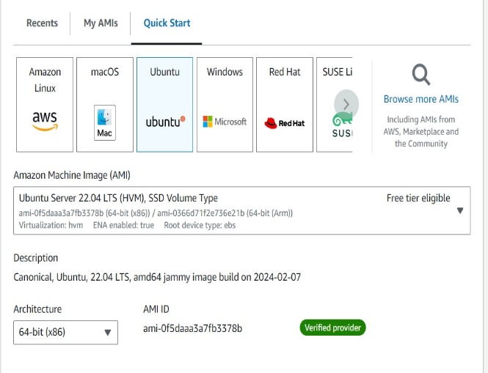

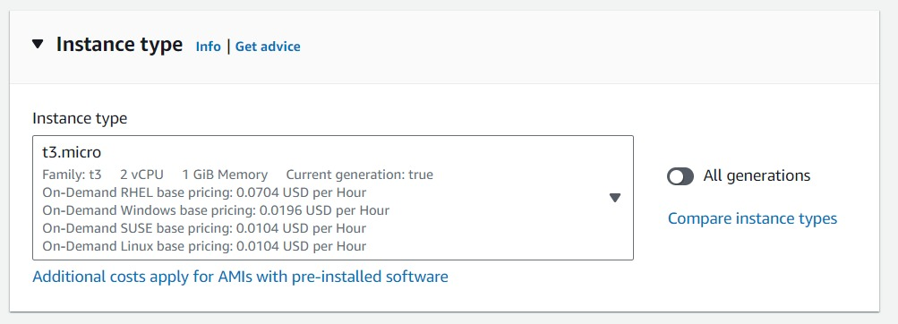

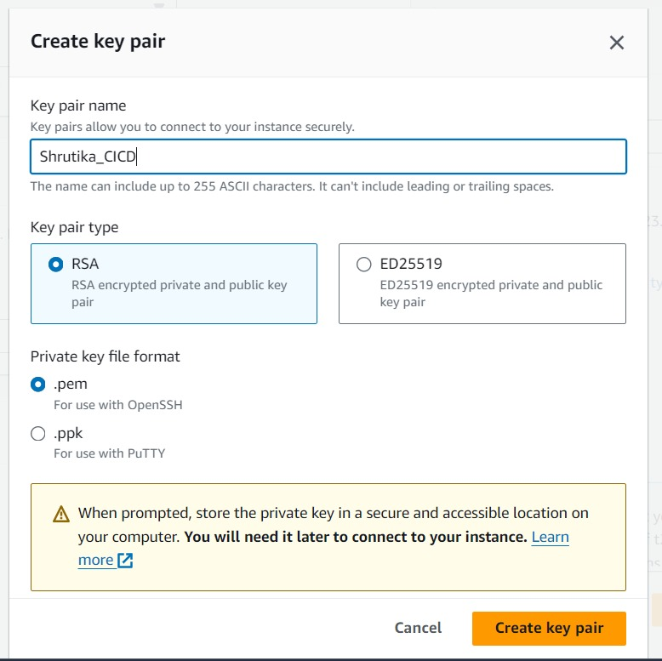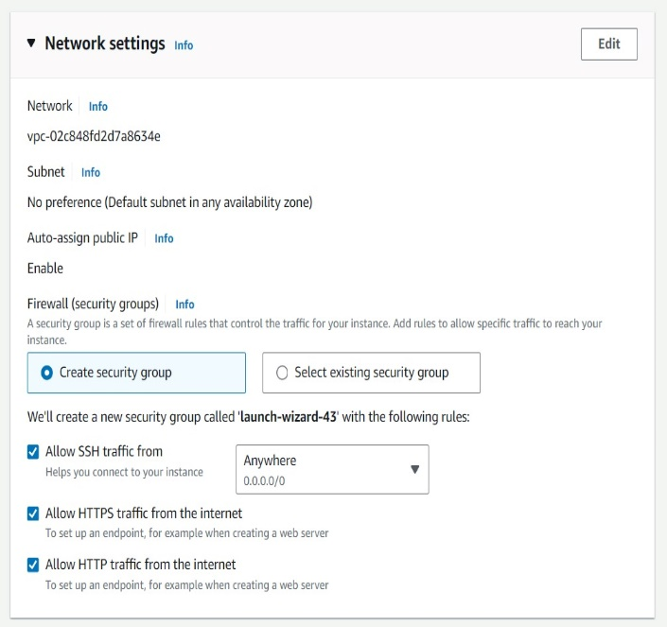

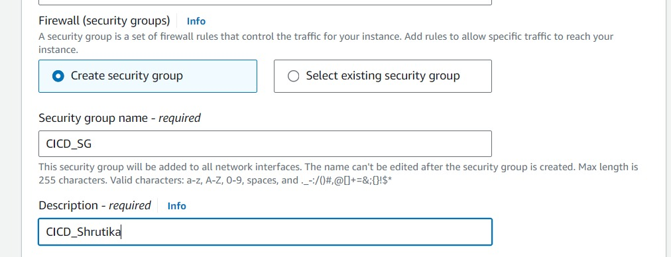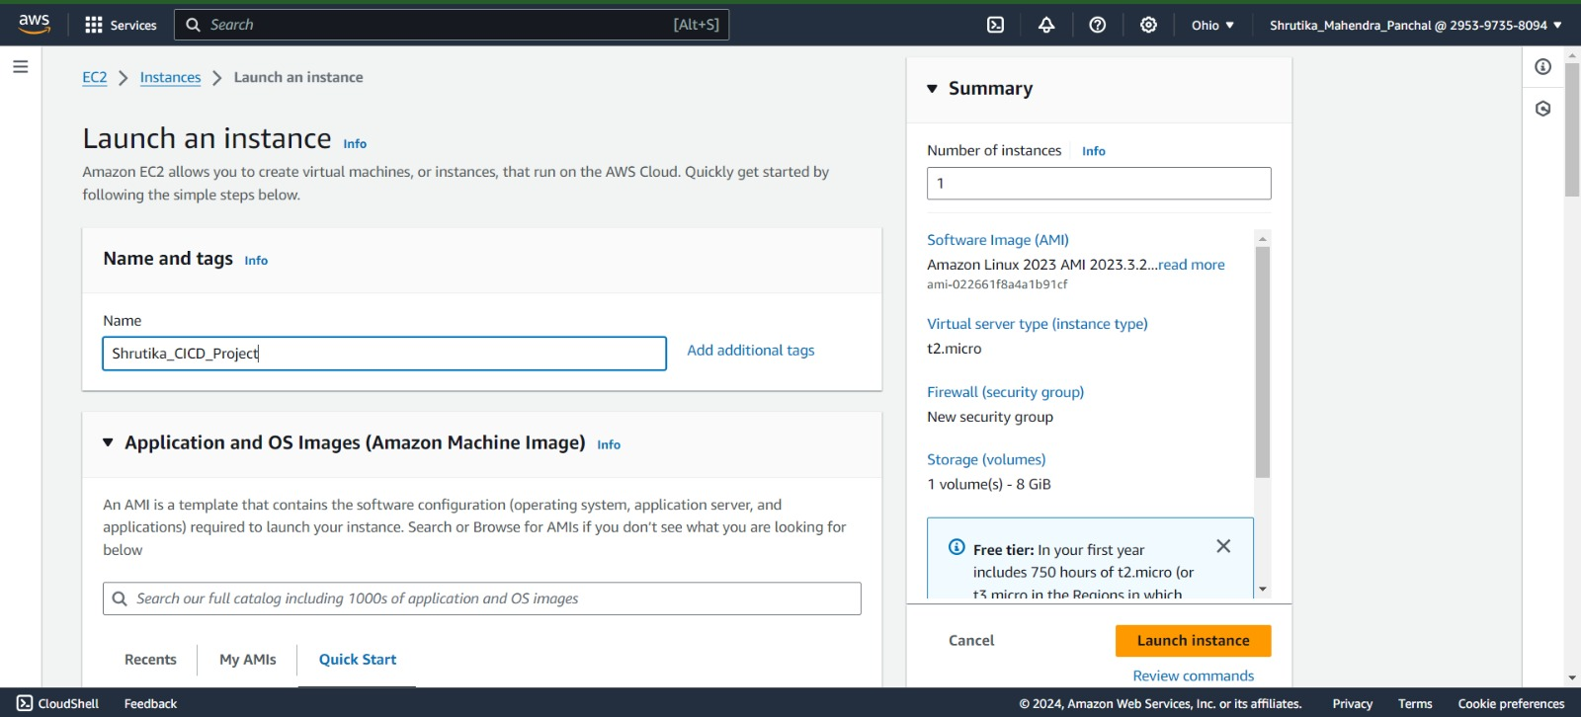

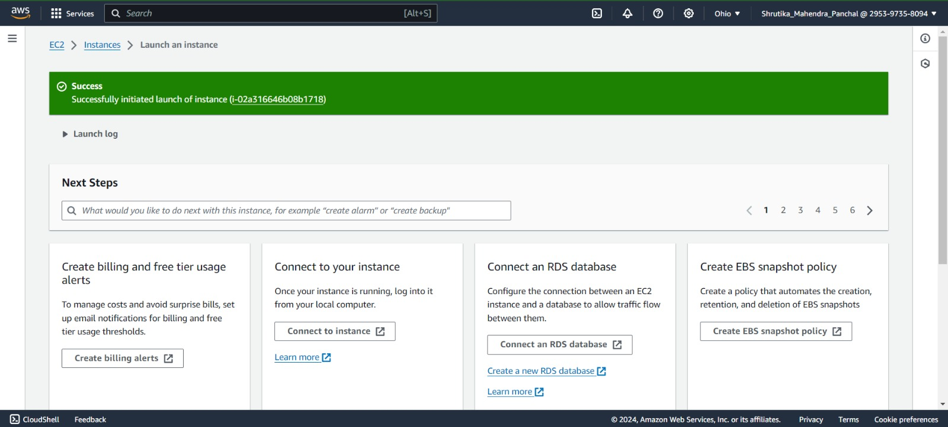

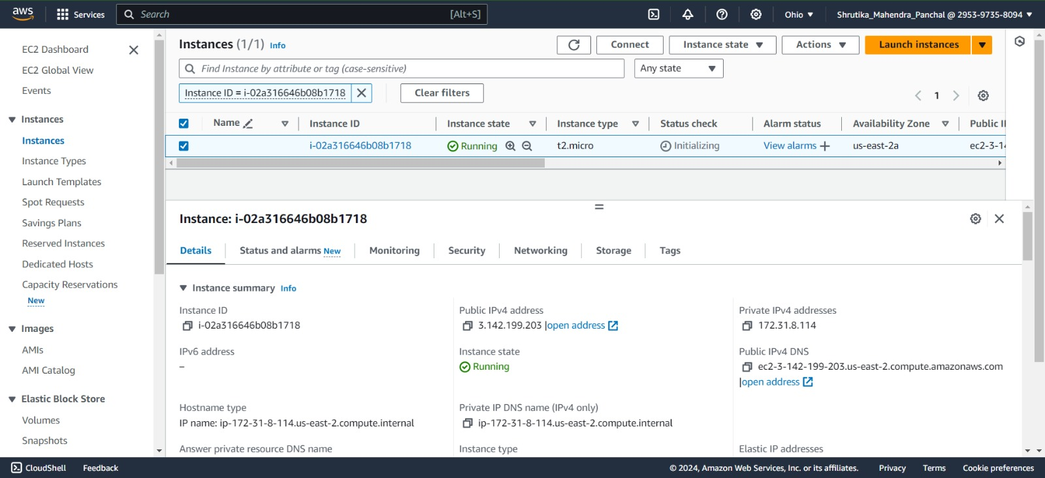

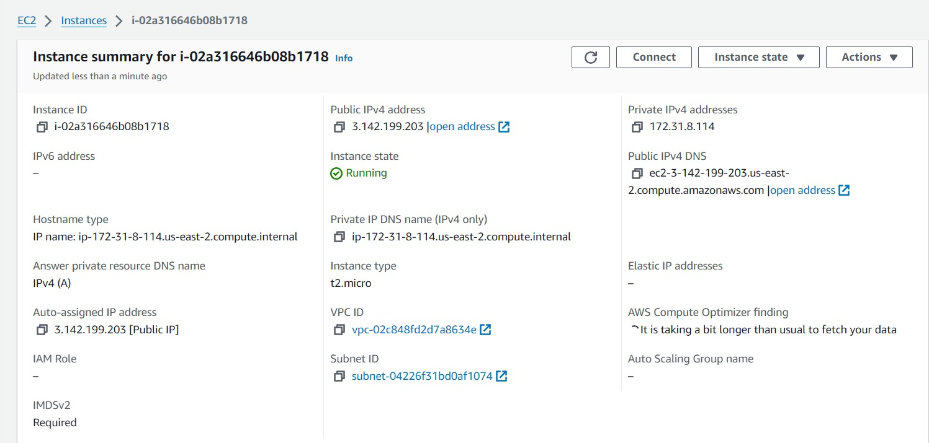

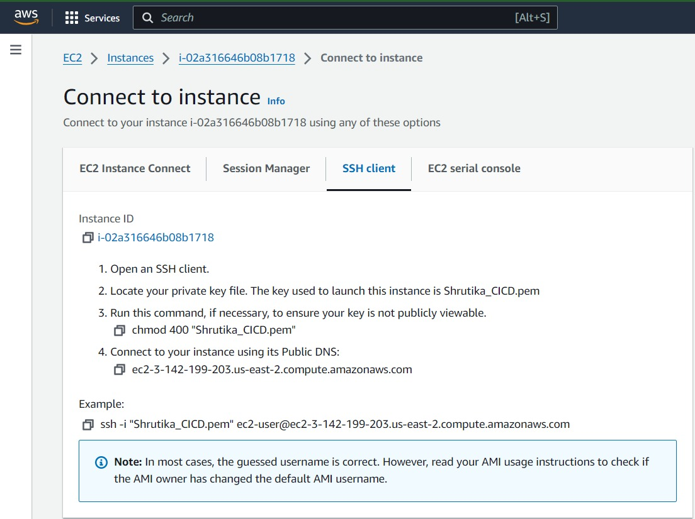

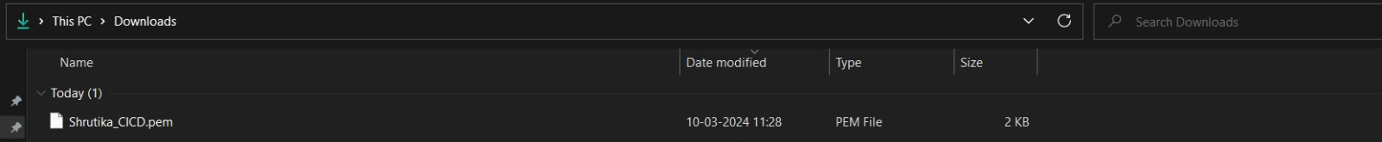

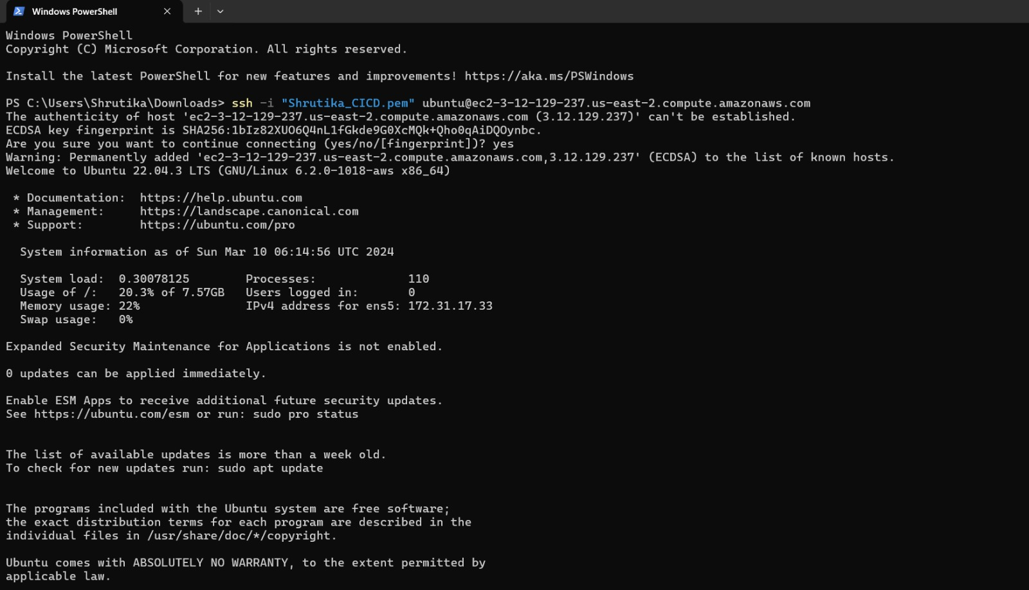

**Install NGINX :**

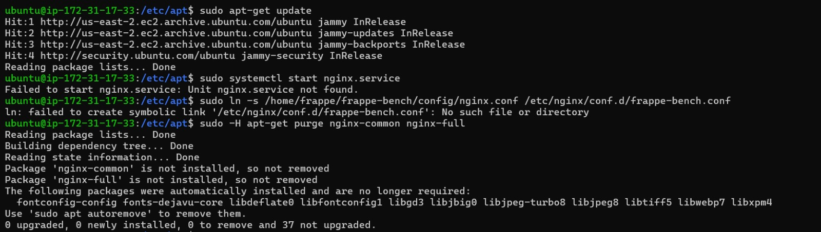

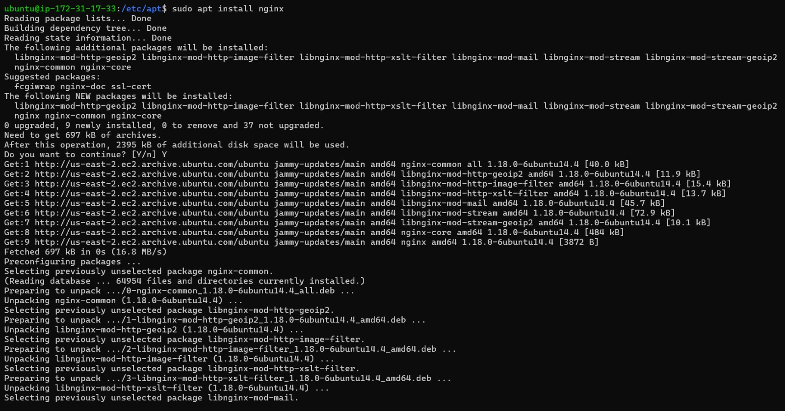

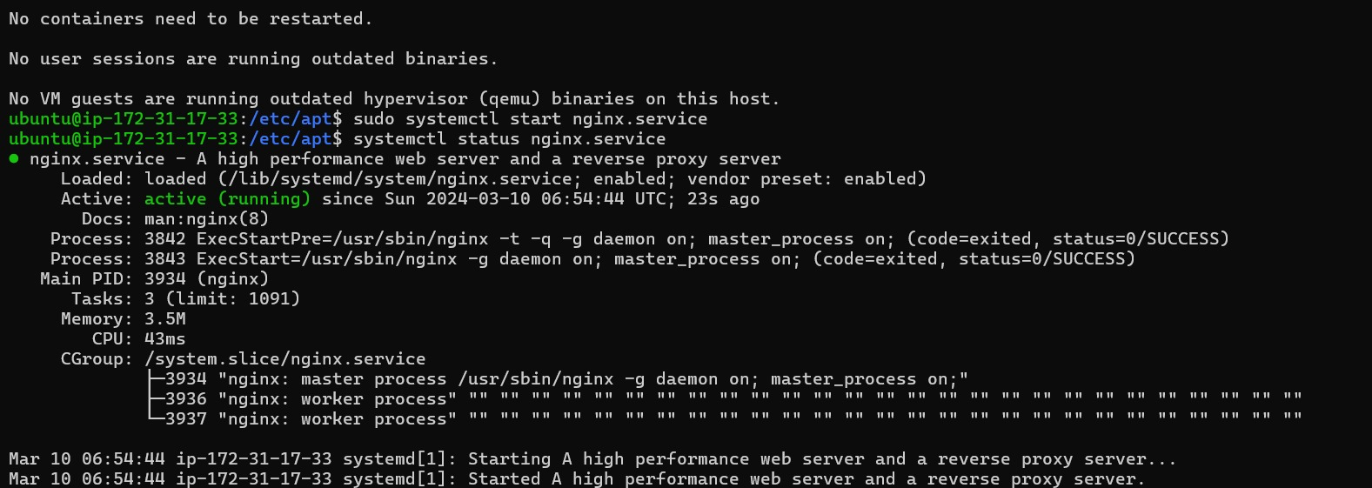

Commands Used : sudo apt-get update

sudo apt install nginx

systemctl start nginx.service

systemctl status nginx.service (!wq to exit)

systemctl enable nginx.service

Task 3: Write a Python Script to Check for New Commits

Create a Python script to check for new commits using the GitHub API.

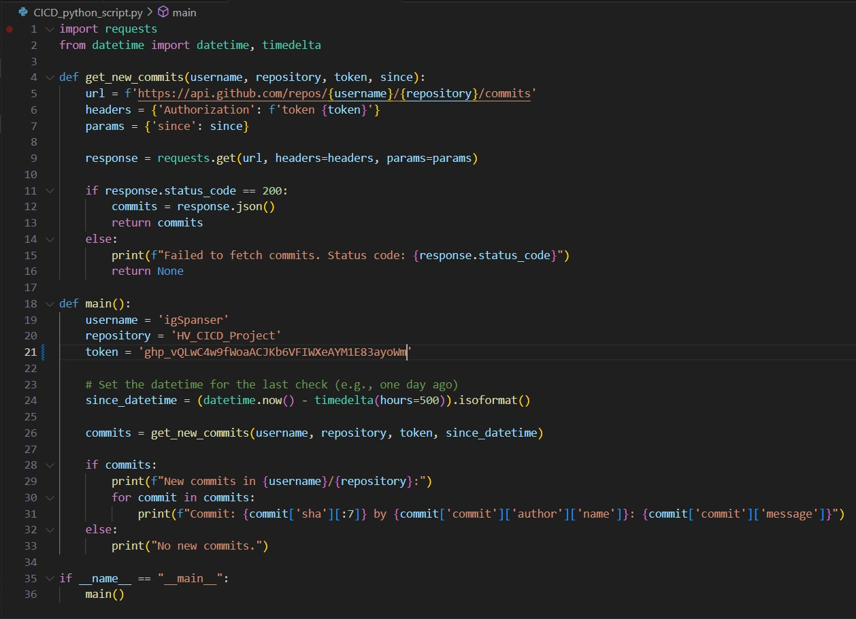

Task 4: Write a Bash Script to Deploy the Code

Create a bash script to clone the latest code and restart Nginx.

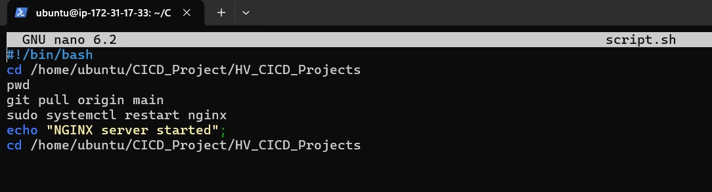

Task 5: Set Up a Cron Job to Run the Python Script

Create a cron job to run the Python script at regular intervals.

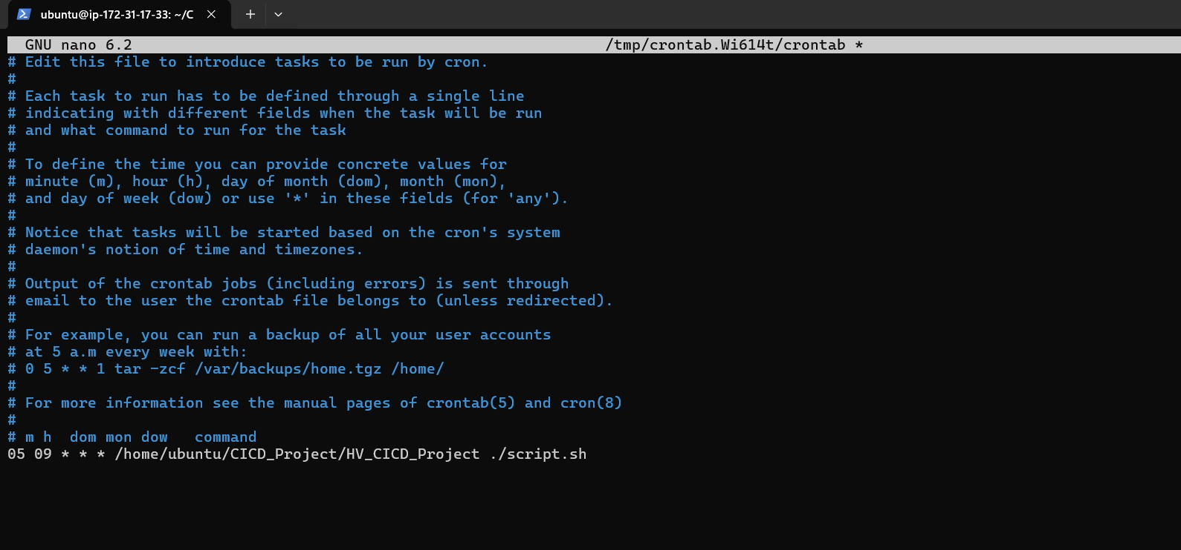

Task 6: Test the Setup

Make a new commit to the GitHub repository and check that the changes are automatically deployed.

